|  |  |
| --- | --- |
| Date | 17 February 2026 |
| Team ID | LTVIP2026TMIDS44629 |
| Project Name | Measuring the Pulse of Prosperity: An Index of Economic Freedom Analysis |
| Maximum Marks |  |

**PROJECT REPORT**

**Measuring the Pulse of Prosperity: An Index of Economic Freedom Analysis**

**1. INTRODUCTION**

**1.1 Background**

In today’s interconnected global economy, economic freedom plays a vital role in shaping a nation’s prosperity, investment climate, and overall quality of life. Governments, policymakers, researchers, and investors rely on structured economic indicators to evaluate how regulatory efficiency, rule of law, market openness, and government size influence national growth.

Globally recognized frameworks such as the The Heritage Foundation and the Fraser Institute publish economic freedom indices that measure countries across multiple dimensions. However, raw datasets from these reports are often complex, multi-dimensional, and difficult to interpret in spreadsheet format.

Without interactive analytical tools, identifying trends, comparing countries, and analyzing year-over-year improvements becomes challenging. Data visualization platforms like Tableau transform structured economic datasets into interactive dashboards, enabling stakeholders to explore patterns, benchmark nations, and make informed policy or investment decisions.

**1.2 Project Overview**

**Measuring the Pulse of Prosperity: An Index of Economic Freedom Analysis** is a Tableau-based data visualization project designed to analyze and present global economic freedom scores across countries and time periods.

This project focuses on:

* Country-wise Economic Freedom Score distribution
* Regional comparison of economic performance
* Component-wise analysis (Rule of Law, Government Size, Regulatory Efficiency, Market Openness)
* Year-over-Year (YoY) score comparison
* Identification of top-performing and underperforming economies
* Interactive storytelling using Tableau Story

The dashboard converts raw CSV datasets into actionable insights that support economic research, policy evaluation, and strategic decision-making.

**1.3 Objectives**

The main objectives of this project are:

* To design an interactive Economic Freedom analytics dashboard
* To analyze country and region-wise performance
* To identify trends and patterns across years
* To compare Year-over-Year economic freedom growth
* To present insights through story-based visualization
* To publish dashboards for web accessibility

**2. IDEATION PHASE**

**2.1 Problem Statement**

Many organizations and policymakers lack a centralized, interactive platform to analyze economic freedom trends globally. Economic datasets stored in static Excel sheets limit the ability to:

* Identify long-term growth trends
* Compare regional economic strength
* Evaluate policy effectiveness
* Understand component-level contributions

This results in slower decision-making and limited strategic insight into national and regional economic development.

**2.2 Target Users**

The primary users of this dashboard include:

* Policy Makers
* Economic Researchers
* Financial Analysts
* Investment Strategists
* Academic Institutions
* International Business Consultants

**2.3 Empathy Map**

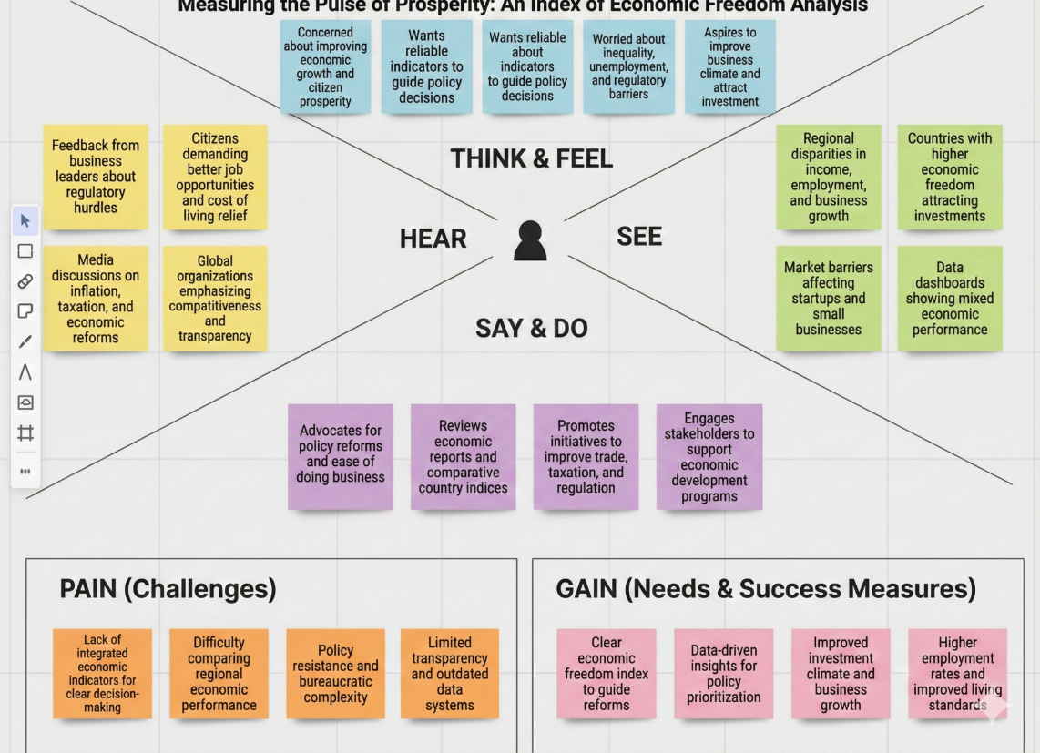

**Higher employment rates**

**THINK & FEEL**

* Concerned about national economic performance
* Curious about global competitiveness rankings
* Pressured to improve economic indicators
* Seeks reliable data for policy recommendations
* Aspires to improve economic stability and growth

**HEAR**

* Discussions on regulatory reforms
* International competitiveness reports
* Investor concerns about economic stability
* Media coverage on economic rankings

**SEE**

* Variations in economic freedom across regions
* Developed vs developing country gaps
* Policy-driven economic shifts
* Long-term score fluctuations

**SAY & DO**

* Reviews annual economic reports
* Conducts comparative country analysis
* Presents economic insights to stakeholders
* Recommends policy adjustments

**PAIN (Fears & Frictions)**

* Scattered global datasets
* Difficulty in comparing multi-year performance
* Limited visualization of component contributions
* Manual and time-consuming analysis

**GAIN (Needs & Success Measures)**

* Clear country ranking visualizations
* Regional comparison dashboards
* Component-wise performance breakdown
* Faster analytical insights
* Data-driven economic strategy formulation

**3. REQUIREMENT ANALYSIS**

**3.1 Functional Requirements**

* Interactive filters (Country, Region, Year, Economic Component)
* Country ranking charts
* Regional comparison visuals
* Year-over-Year growth analysis
* KPI indicators (Overall Score, Rank, Growth %, Component Averages)
* Story-based navigation

**3.2 Non-Functional Requirements**

* Dashboard loading time under 5 seconds
* Accurate score calculations and aggregations
* Clean and responsive layout
* Secure publishing via Tableau Public
* Scalable dataset structure for future data integration

**3.3 Data Requirements**

The dashboard uses Economic Freedom datasets containing:

* Country Name
* Region
* Overall Economic Freedom Score
* Global Rank
* Rule of Law Score
* Government Size Score
* Regulatory Efficiency Score
* Market Openness Score
* Year (e.g., 2022 & 2023)
* Total Records: 150+ countries per year

**4. SYSTEM DESIGN**

**4.1 Data Flow Diagram**

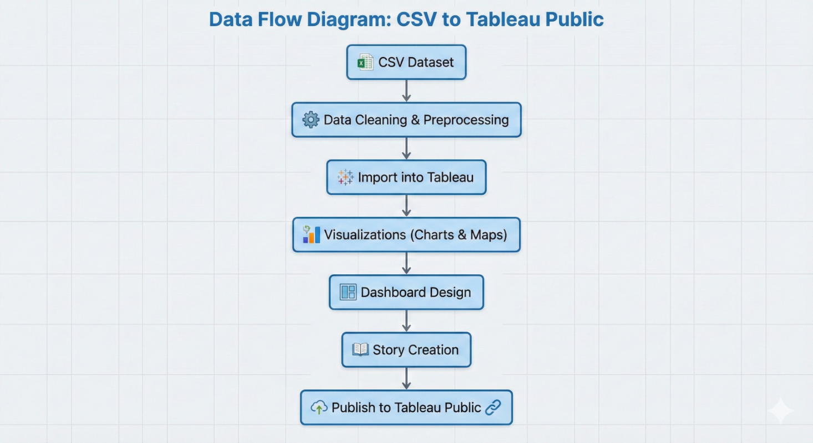

**4.2 Solution Architecture**

* **User Interface Layer**
* Tableau Web Dashboard
* Interactive filters and KPI cards
* **Application Layer**
* Tableau Calculated Fields
* Filtering, aggregation, and business logic
* **Data Layer**
* CSV retail datasets
* Optional cloud storage
* **Deployment Layer**
* Tableau Public / Tableau Server
* Embedded via HTML iframe

**5. PROJECT PLANNING & SCHEDULING**

| **Phase** | **Task** | **Time (Days)** |
| --- | --- | --- |
| Phase-1 | Data Collection | 1 |
| Phase-2 | Data Cleaning & Preprocessing | 2 |
| Phase-3 | Visualizations Development | 2 |
| Phase-4 | Dashboard & Story Creation | 2 |
| Phase-5 | Performance Testing | 1 |
| Phase-6 | Web Integration & Publishing | 1 |
| Phase-7 | Report & Documentation | 3 |

**6. FUNCTIONAL AND PERFORMANCE TESTING**

**6.1 Performance Testing**

* Data Loaded: 150+ countries per year
* Filters Used: Country, Region, Year, Component
* Calculated Fields: YoY Growth %, Rank Change, Component Contribution %
* Visualizations: 10–15
* Result: Smooth dashboard performance with response time under 3–5 seconds

**7. RESULTS**

**Output Screenshots**

* 2022 Economic freedom score



* **Index score based on unemployment rate**



* **Index score based on population**



* **Inflation rate in different countries**



* **Dashboard**

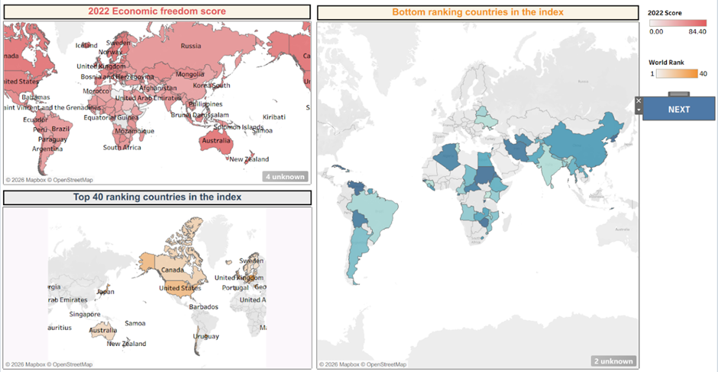

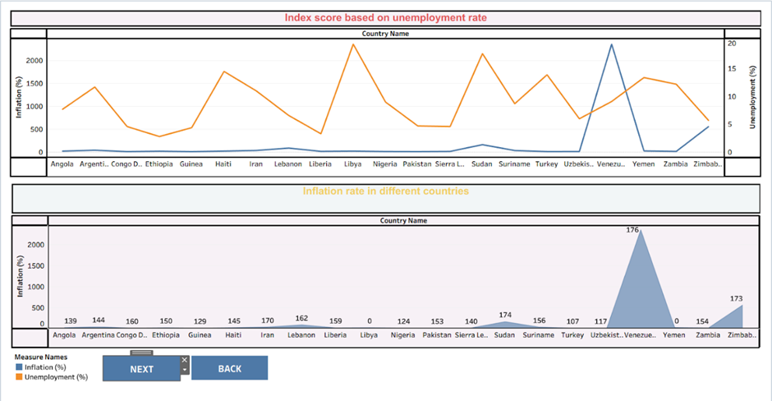

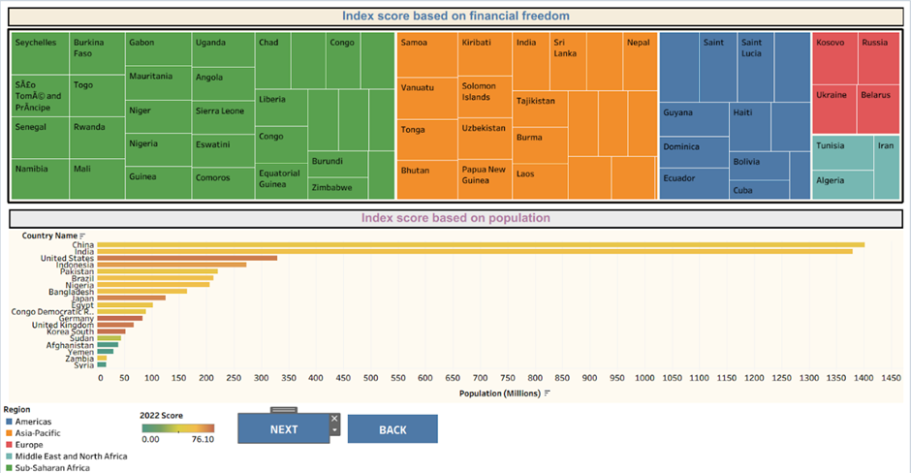

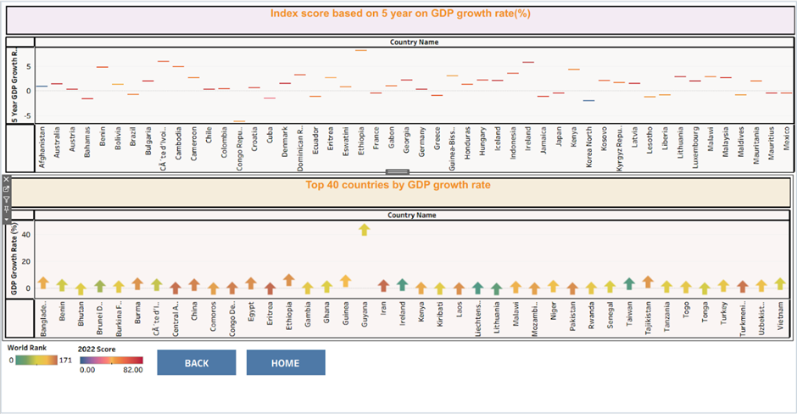

* **Story**

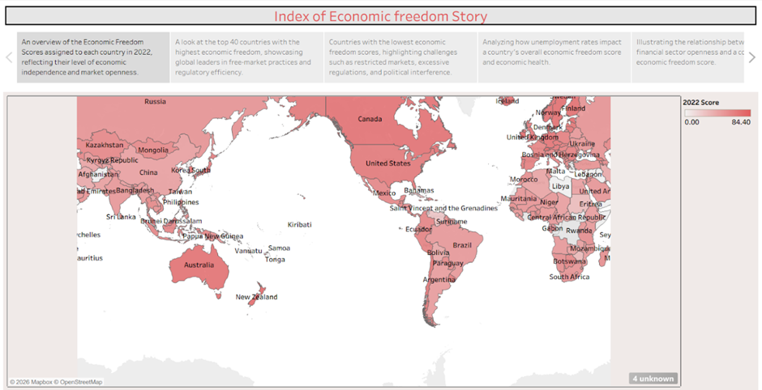

**8. ADVANTAGES & DISADVANTAGES**

* **Advantages**
* Centralized economic analytics platform
* Easy comparison of countries and regions
* Interactive and story-driven insights
* Supports data-driven policy evaluation
* Enhances research and investment analysis
* **Disadvantages**
* Requires Tableau expertise
* Uses static datasets (if not connected to live updates)
* Scalability may require cloud-based integration

**9. CONCLUSION**

This project demonstrates how Tableau can transform complex global economic datasets into meaningful analytical insights. The dashboard simplifies multi-dimensional economic indicators into interactive visualizations, enabling policymakers, researchers, and analysts to monitor trends, evaluate national performance, and understand the pulse of global prosperity.

**10. FUTURE SCOPE**

* Integration of real-time global economic databases
* Predictive modeling for economic growth forecasting
* AI-based policy impact analysis
* Mobile-responsive dashboards
* Expansion into GDP, inflation, trade, and investment analytics

**11. APPENDIX**

**Data set Link:-**

CSV file used in Tableau

<https://drive.google.com/file/d/1EBIa1LtM3Ni2Uh3nekLB6wt3263Q3NeX/view?usp=share_link>

**Tableau Publish:-**

1. **Dashboard:**

<https://public.tableau.com/views/IndexofEconomicfreedomDasashboard_17717400904530/Dashboard1?:language=en-US&:sid=&:redirect=auth&:display_count=n&:origin=viz_share_link>

1. **Story**

<https://public.tableau.com/views/StoryofIndexofEconomicfreedom/Story1?:language=en-US&:sid=&:redirect=auth&:display_count=n&:origin=viz_share_link>

**Project Demo:-**

[**https://drive.google.com/file/d/1uQdswwCBUd7nZYPe09DfrOt7GGjmlpem/view?usp=sharing**](https://drive.google.com/file/d/1uQdswwCBUd7nZYPe09DfrOt7GGjmlpem/view?usp=sharing)